Department of Computer Science and Engineering (Data Science)
CSDS-A | Batch A1 (CSE - Data Science, Section A)
AI Health Insurance Assistance Using LLM + RAG
(PolicyLens)
S.No. | Student name | Roll / hall ticket no.
1 | G.PRANATHI | 23K91A6764
2 | CH.AISHWARYA | 23K91A6747
3 | BHAVANSH MANE | 23K91A6728
4 | B.DEEKSHITH | 24K95A6701
Under the guidance of: [GUIDE NAME], [DESIGNATION]
DESIGN AND IMPLEMENTATION
This document describes the design of PolicyLens and how it was implemented: the architecture, the modules, the database schema, the API, key code walkthroughs, and the reasoning behind the main implementation decisions.

1 System Architecture
PolicyLens is a single-machine application: a React web app, a FastAPI backend, local storage and three CPU models, with the Gemini API as the only external service. The figure below shows the layers.
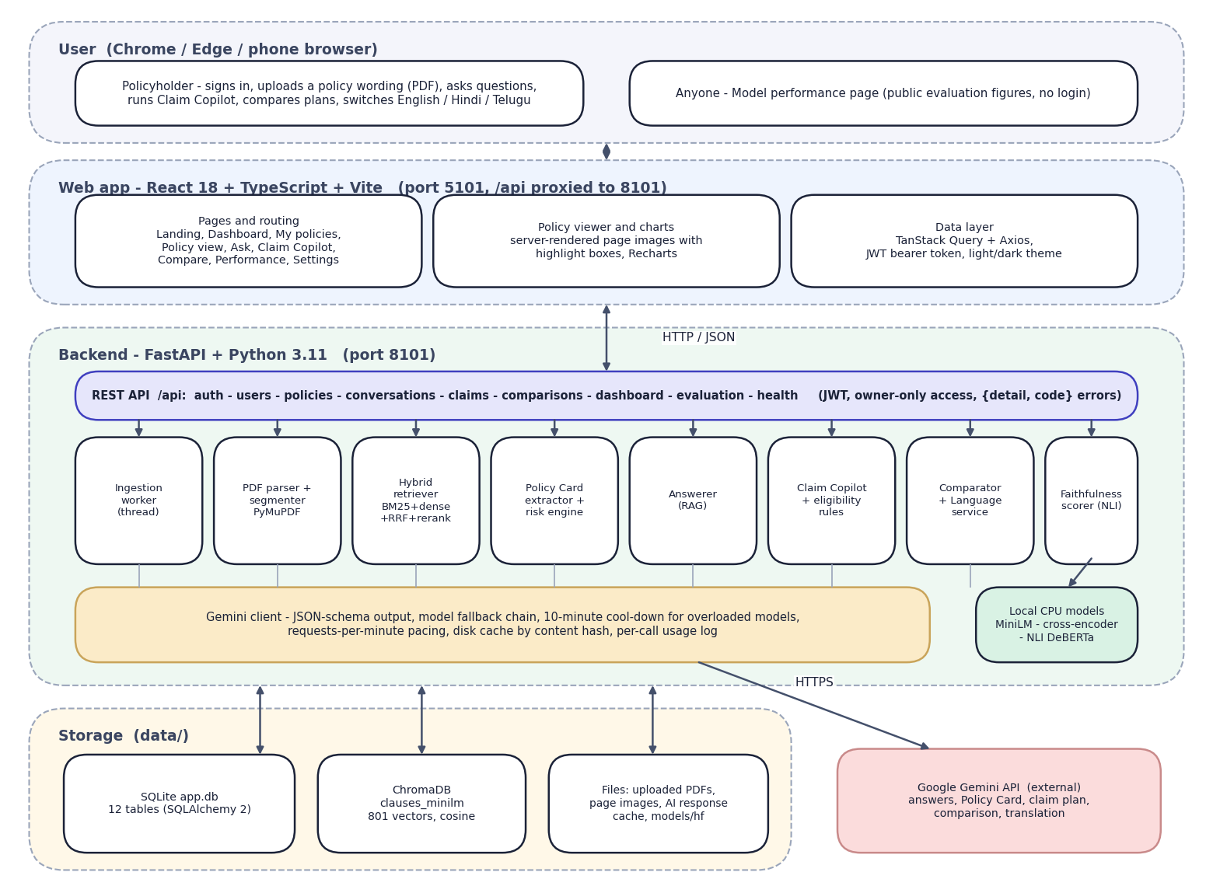
Fig. 1: System architecture of PolicyLens
The diagram shows five layers. At the top is the user's browser: a policyholder, and any visitor to the public Model performance page. Below it is the React web application, served by Vite on port 5101, which proxies every /api call to the backend. The backend is a FastAPI application on port 8101. Its REST layer exposes authentication, users, policies, conversations, claims, comparisons, the dashboard, evaluation and health endpoints, and passes work to eight services: the ingestion worker, the PDF parser and segmenter, the hybrid retriever, the Policy Card extractor with the risk engine, the answerer, Claim Copilot with the eligibility rules, the comparator with the language service, and the faithfulness scorer.
Every request to a language model goes through one Gemini client, which handles the JSON schema, the fallback chain, the pacing and the cache. Three small models run locally on the CPU. Storage is local: SQLite for records, ChromaDB for the clause vectors, and plain files for PDFs, page images and the response cache. The only external service is the Gemini API.
The design follows four principles. Ground everything in the document: the only text the language model may use is the clauses that retrieval hands it, tagged so that each statement can be traced. Check independently: faithfulness, quote verification and eligibility rules are computed outside the model that wrote the text. Keep the heavy work local: retrieval, re-ranking and scoring run on the CPU, which keeps documents on the user's machine and saves quota. Degrade gracefully: with the Gemini key removed, upload, search and the document viewer still work.

2 Module Design
Table 1: Modules of PolicyLens
Module | Code | Responsibility
REST API | backend/app/api/ | Authentication, policies, chat, claims, comparisons, dashboard, evaluation; consistent {detail, code} errors
Ingestion worker | services/ingestion.py | Runs parse, index and extract in a background thread; resumes unfinished work after a restart
PDF parser | services/pdf_parser.py | Lines with page, position and font; removes running headers and footers; two-column reading order; joins letter-spaced headings; tables as rows; rejects scans
Segmenter | services/segmenter.py | Clause starts (4.2.1, Def. 5, Excl03, headings); IRDAI exclusion-code items as separate clauses; heading path; chunks of 12-380 words with highlight boxes
Hybrid retriever | ml/retrieval/ | BM25 with insurance synonyms; MiniLM + ChromaDB; Reciprocal Rank Fusion; cross-encoder re-rank
Extractor | services/extractor.py | One schema-constrained Gemini call; quote location to verify clause and page
Risk engine | services/risk_engine.py | Rules on extracted numbers plus AI findings, de-duplicated, with severity
Answerer | services/answerer.py | Retrieval, abstention rule, rule/table context, cited answer, tag filtering
Faithfulness scorer | ml/faithfulness.py | NLI support of each claim against sentence windows of its cited clauses, number check
Claim Copilot | services/claim_copilot.py, eligibility.py | Multi-query retrieval; calculated pre-checks and estimate; structured verdict, checklist and steps
Comparator | services/comparator.py | Field-by-field table with better markers and AI trade-offs citing both policies
Language service | services/language.py | Script detection; query translation; card and risk translation (cached)
Gemini client | services/gemini_client.py | JSON-schema calls, fallback chain, cool-down, RPM pacing, disk cache, usage log
Evaluation harness | ml/ | Retrieval, answer, claim and extraction evaluations; metrics, plots, run folders

3 Database Design
The database is SQLite, created by SQLAlchemy 2. Large structured results (citations, the Policy Card, claim results) are stored as JSON columns, because they are read and written whole and are never queried field by field.
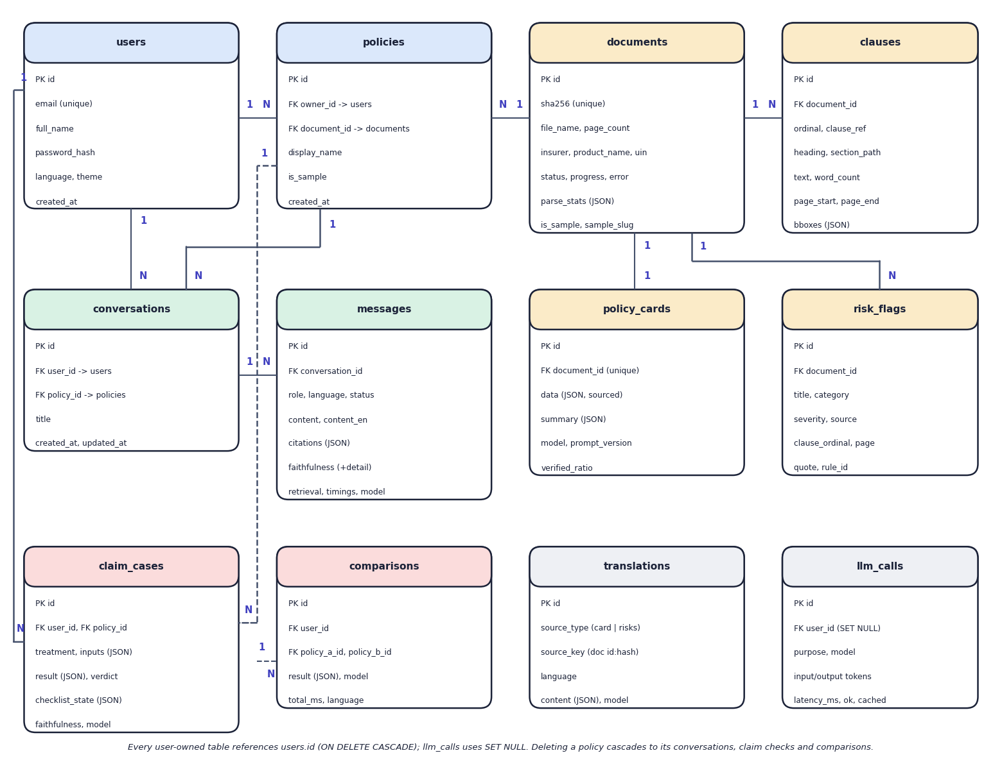
Fig. 2: Entity-relationship diagram (12 tables)
Twelve tables are created by SQLAlchemy in SQLite. A user owns policies; a policy points to a document, which is shared by content hash so that the same PDF is processed once even if two users upload it. A document has many clauses and risk flags and at most one Policy Card. Conversations belong to a user and a policy and contain messages. Claim cases and comparisons belong to a user and reference policies. Translations are cached by a key built from the document and a content hash, and the llm_calls table logs every model request.
Table 2: Database tables
Table | Purpose | Key columns
users | Accounts | email (unique), full_name, password_hash (bcrypt), language, theme
documents | One parsed PDF, shared by content hash | sha256 (unique), file_name, page_count, insurer, product_name, uin, status, progress, parse_stats
policies | A document in one user's library | owner_id, document_id, display_name, is_sample
clauses | Retrievable chunks of a document | document_id, ordinal, clause_ref, heading, section_path, text, page_start/end, bboxes (JSON), word_count
policy_cards | Extracted card (one per document) | document_id (unique), data (JSON with sources), summary, model, prompt_version, verified_ratio
risk_flags | Risk highlights | document_id, title, category, severity, explanation, clause_ordinal, page, quote, source (rule/ai), rule_id
conversations | A chat about one policy | user_id, policy_id, title
messages | Questions and answers | conversation_id, role, content, content_en, language, status, citations, faithfulness (+detail), retrieval, timings, model
claim_cases | Claim Copilot checks | user_id, policy_id, treatment, inputs, result, verdict, checklist_state, faithfulness
comparisons | Plan comparisons | user_id, policy_a_id, policy_b_id, result, model
translations | Cached Hindi/Telugu translations | source_type, source_key, language, content
llm_calls | Usage log of model requests | user_id (SET NULL), purpose, model, input/output tokens, latency_ms, ok, cached

Deleting a user cascades to their policies, conversations, claim cases and comparisons. A document row uses RESTRICT from policies, so a shared document is never removed while a policy still points to it.

4 Application Architecture
The backend is organised in layers: routers in api/ validate input and enforce ownership; services in services/ and ml/ hold the logic; models in models/ map to tables; schemas in schemas/ define request and response types with Pydantic v2; core/ holds configuration, the database session, error types, logging and security. A background thread (the ingestion worker) takes jobs from a queue so that upload returns immediately; the web app polls /policies/{id}/status every two seconds until the status is ready.
The frontend is a single-page React application in TypeScript. React Router provides the routes with lazy-loaded pages; TanStack Query caches server data and drives the polling; Axios attaches the JWT; Tailwind CSS and shadcn/ui components provide the styling; Recharts draws the dashboard and the Model performance charts. The viewer shows page images that the backend renders with the highlight rectangles supplied by the parser, so the browser needs no PDF library.

5 API Design
The API is REST over JSON under /api, with 42 route handlers. Interactive documentation (Swagger UI) is served at /docs. All endpoints except health, registration, login and the evaluation endpoints require Authorization: Bearer <token>. Errors are always {"detail": "readable message", "code": "machine_code"}.
Table 3: API endpoints
Group | Endpoints
Health | GET /health
Auth and user | POST /auth/register, POST /auth/login, GET /auth/me, PATCH /users/me, POST /users/me/password, GET /users/languages
Policies | GET/POST /policies, POST /policies/samples, GET/PATCH/DELETE /policies/{id}, GET /policies/{id}/status, /file, /pages, /pages/{n}, /clauses, /clauses/{ordinal}, /card, /risks, POST /policies/{id}/extract, POST /policies/{id}/search
Chat | POST/GET /conversations, GET/DELETE /conversations/{id}, POST /conversations/{id}/messages
Claims | POST/GET /claims, GET/DELETE /claims/{id}, PATCH /claims/{id}/checklist
Compare | POST/GET /comparisons, GET/DELETE /comparisons/{id}
Dashboard and evaluation | GET /dashboard/summary; GET /evaluation/latest, /evaluation/runs, /evaluation/runs/{run}, /evaluation/runs/{run}/plots/{file}

Example: ask a question. POST /api/conversations/{id}/messages with the body below returns the stored question and the answer with its citations, faithfulness score, retrieval trace and timings; the status is answered, partial or not_in_policy.
Listing: Request body
{"question": "Is cataract surgery covered and after how long?", "language": "en"}

Example: Claim Copilot. POST /api/claims needs only policy_id and treatment; the other fields sharpen the result.
Listing: Request body
{"policy_id": 4, "treatment": "Knee replacement", "hospitalization_type": "planned", "claim_mode": "cashless",
"policy_start_date": "2023-10-01", "insured_age": 64, "pre_existing": "no", "estimated_cost": 350000, "language": "en"}

The response contains the verdict (covered, partly_covered, not_covered, needs_info), the reasons with their clauses, the pre-checks (pass, fail, warning, unknown), the document checklist, the claim steps, the estimate and the timings.

6 Key Code Walkthroughs

6.1 Reciprocal Rank Fusion
The fusion function is eleven lines. It adds 1/(k + rank) for each list in which an item appears and sorts by the total.
Listing: reciprocal_rank_fusion() in ml/retrieval/fusion.py
def reciprocal_rank_fusion(rankings: Sequence[Sequence[Hashable]], k: int = 60,
weights: Sequence[float] | None = None) -> list[tuple[Hashable, float]]:
weights = weights or [1.0] * len(rankings)
scores: dict[Hashable, float] = {}
for ranking, weight in zip(rankings, weights):
for rank, item in enumerate(ranking, start=1):
scores[item] = scores.get(item, 0.0) + weight / (k + rank)
return sorted(scores.items(), key=lambda kv: kv[1], reverse=True)

6.2 The abstention rule and the call to the model
In answer_question(), after retrieval, the answerer checks the two scores. Only if the rule does not fire is the model called.
Listing: Abstention check in services/answerer.py
if not retrieved or (result.best_score < ABSTAIN_BELOW and best_keyword < KEYWORD_FLOOR):
timings["total_ms"] = round((time.perf_counter() - t0) * 1000)
text = NOT_IN_POLICY.get(language, NOT_IN_POLICY["en"])
return AnswerResult("not_in_policy", text, NOT_IN_POLICY["en"], [], score_claims([], {}), [],
retrieval_info, timings, None, language, {"abstained_before_llm": True})

6.3 Dropping citations that were not retrieved
The model can only cite clauses it was given. Any tag that does not belong to a retrieved clause is removed from the text, and unknown ordinals are discarded from the claims, so a citation can never point to something the system did not show.
Listing: Citation filtering in services/answerer.py
# Keep only citations to clauses we actually retrieved.
def clean(text: str) -> str:
text = normalise_tags(text)
return _TAG.sub(lambda m: m.group(0) if int(m.group(1)) in by_ordinal else "", text).replace(" ", " ")

answer, answer_en = clean(out.answer), clean(out.answer_en)
claims: list[ClaimInput] = []
for c in out.claims:
ordinals = [int(m) for tag in c.clauses for m in re.findall(r"\d+", tag) if int(m) in by_ordinal]
claims.append(ClaimInput(c.text_en, ordinals))
cited = sorted({int(m) for m in _TAG.findall(answer_en + " " + answer)} | {o for c in claims for o in c.clause_ordinals})
citations = [citation_for(by_ordinal[o], [c.text for c in claims if o in c.clause_ordinals] or [answer_en])
for o in cited if o in by_ordinal]

6.4 Faithfulness: support of a claim
The support of each claim is the best entailment over the evidence windows, with a lexical backstop for near-verbatim restatements and a penalty when a number is not found in the cited text.
Listing: Claim support in ml/faithfulness.py
claim_numbers = _numbers(claim.text)
evidence_numbers = _numbers(evidence_text)
numbers_ok = claim_numbers.issubset(evidence_numbers) or not claim_numbers
# Lexical backstop: a near-verbatim restatement of the clause is supported even when the
# small NLI model is unsure about long legal sentences.
overlap = token_overlap(claim.text, evidence_text)
support = max(entail, 0.75 * overlap if overlap >= 0.8 else 0.0)
if not numbers_ok:
support *= 0.5

6.5 Calculated claim estimate
The estimate is plain arithmetic on the Policy Card values, not model output.
Listing: Cost estimate in services/eligibility.py
cost = inputs.get("estimated_cost")
if isinstance(cost, (int, float)) and cost > 0:
deductible = card.get("deductible") or {}
ded = deductible.get("number") if deductible.get("found") and deductible.get("unit") == "INR" else 0
payable = max(0.0, float(cost) - float(ded or 0))
cap_note = None
if sub_hit and sub_hit.get("unit") == "INR" and isinstance(sub_hit.get("number"), (int, float)):
if payable > sub_hit["number"]:
payable = float(sub_hit["number"])
cap_note = f"capped by the sub-limit ({sub_hit.get('value')})"
copay_amount = payable * (copay_pct or 0) / 100
payable -= copay_amount

7 Implementation Decisions and Reasoning
Table 4: Implementation decisions
Decision | Why
Local embeddings, re-ranker and NLI model | No API quota, deterministic, offline; the faithfulness check is independent of the model that wrote the answer
Hybrid retrieval with a pool that always includes each retriever's top 8 | Keyword search is precise for exclusion codes and medical terms; embeddings handle paraphrase; the re-ranker puts the best clause first
Schema-constrained JSON from Gemini | Predictable structure, no fragile text parsing; every value carries its clause tag and quote
Quote verification of Policy Card values | A value whose quote cannot be found in the text is shown as unverified rather than silently trusted
Clause-aware segmentation instead of fixed windows | A citation must point at one rule and be highlighted on the original page
Rules calculate waiting periods, co-payments and the estimate | Months, ages and money must be exact; the model cannot overrule a failed waiting period
Abstain on two scores, not one | Neither the re-rank score nor the BM25 score separates answerable from out-of-scope questions alone
Server-rendered page images for the viewer | Exact highlight positions from the parser and no PDF library in the browser
Fallback chain and cool-down for Gemini | Free-tier models can be overloaded or out of quota; the app keeps answering and shows which model answered
Response cache keyed by content hash | Re-running the evaluation or re-importing a known PDF does not spend quota twice; a button bypasses the cache
Documents shared by SHA-256 | The same PDF is processed once even if two users upload it
SQLite and ChromaDB, no server to run | One-machine installation by a student or a policyholder
Background ingestion worker with resume | Upload returns at once; unfinished work is resumed after a restart
No training | The task is reading, not predicting; no labelled public data; wordings change every year

8 Security and Error Handling
- Passwords are hashed with bcrypt; a password needs at least eight characters with a letter and a number; login is case-insensitive on the e-mail address.
- Tokens. A signed JWT (HS256, PyJWT) with a 24-hour expiry (JWT_EXPIRE_MINUTES, default 1440). The signing secret is generated by setup.bat in .env; if it is missing the code falls back to a development default, which must be replaced for any shared deployment.
- Ownership. Every policy, conversation, claim check and comparison is tied to its owner and returned only to that user; this is covered by test_policy_flow.py.
- Uploads are validated before they are stored: PDF signature, size limit (25 MB by default), encryption, page count and duplicate hash.
- Secrets (the Gemini key, the JWT secret) live in .env, which is excluded from version control; the API never returns them.
- CORS is limited to the configured origins (the web app on port 5101).
- Error handling. Application errors carry a code and a readable message; validation errors return 422 with details; unexpected errors are logged and returned as a generic message. AI errors are mapped to ai_quota (429), ai_unavailable (503) or ai_not_configured (503), and the web app turns them into plain messages.
- Model-output safety. Output is constrained by a JSON schema, citations are filtered to retrieved clauses, and rule-based checks cannot be overruled by the model. Text inside an uploaded PDF is passed to the model, so a deliberately crafted document could try to instruct it; this was not tested (see Chapter 7).

9 User Interface Design
The web application has twelve pages: the landing page, sign-in and registration, the dashboard, My policies, the policy view (with tabs for the Policy Card, risks, the original document and clause search), Ask your policy, the four-step Claim Copilot wizard, Compare plans, Model performance, Settings and a not-found page. A sidebar on wide screens and a bottom bar on phones give access to the main sections.
Design decisions follow from the purpose of the product. Every fact carries a clause and page chip that opens the original page with the clause highlighted, so that trust never rests on the interface alone. Every answer shows its faithfulness badge, the model that produced it and its response time. Verdicts and severities use colour together with a text label, so the meaning does not depend on colour. The interface is available in light and dark themes, and honours the reduced-motion setting. Screens are shown in Chapter 8 and Appendix C.

10 Installation and Execution
The full guide is docs/03_HOW_TO_RUN.md and Appendix B. In short, on Windows 10 or 11 with Python 3.11 and Node.js LTS:
Table 5: Installation and execution
Step | Command | What it does
1 | setup.bat | Checks Python and Node, creates the virtual environment, installs packages, creates .env, downloads the three local models (about 480 MB), installs the web packages, creates the database, the demo account and the four sample policies, and builds their index
2 | edit .env | Paste the free Gemini API key after GEMINI_API_KEY=
3 | run.bat | Starts the API (port 8101) and the web app (port 5101) and opens http://localhost:5101
4 | demo@policylens.app / Demo@12345 | Sign in to the demo account with four ready sample policies
5 | stop.bat | Stops both servers
6 | venv\Scripts\python ml\run_all.py | Re-runs the full evaluation (about 10 minutes, about 80 Gemini requests)

